Data Warehouse Schema
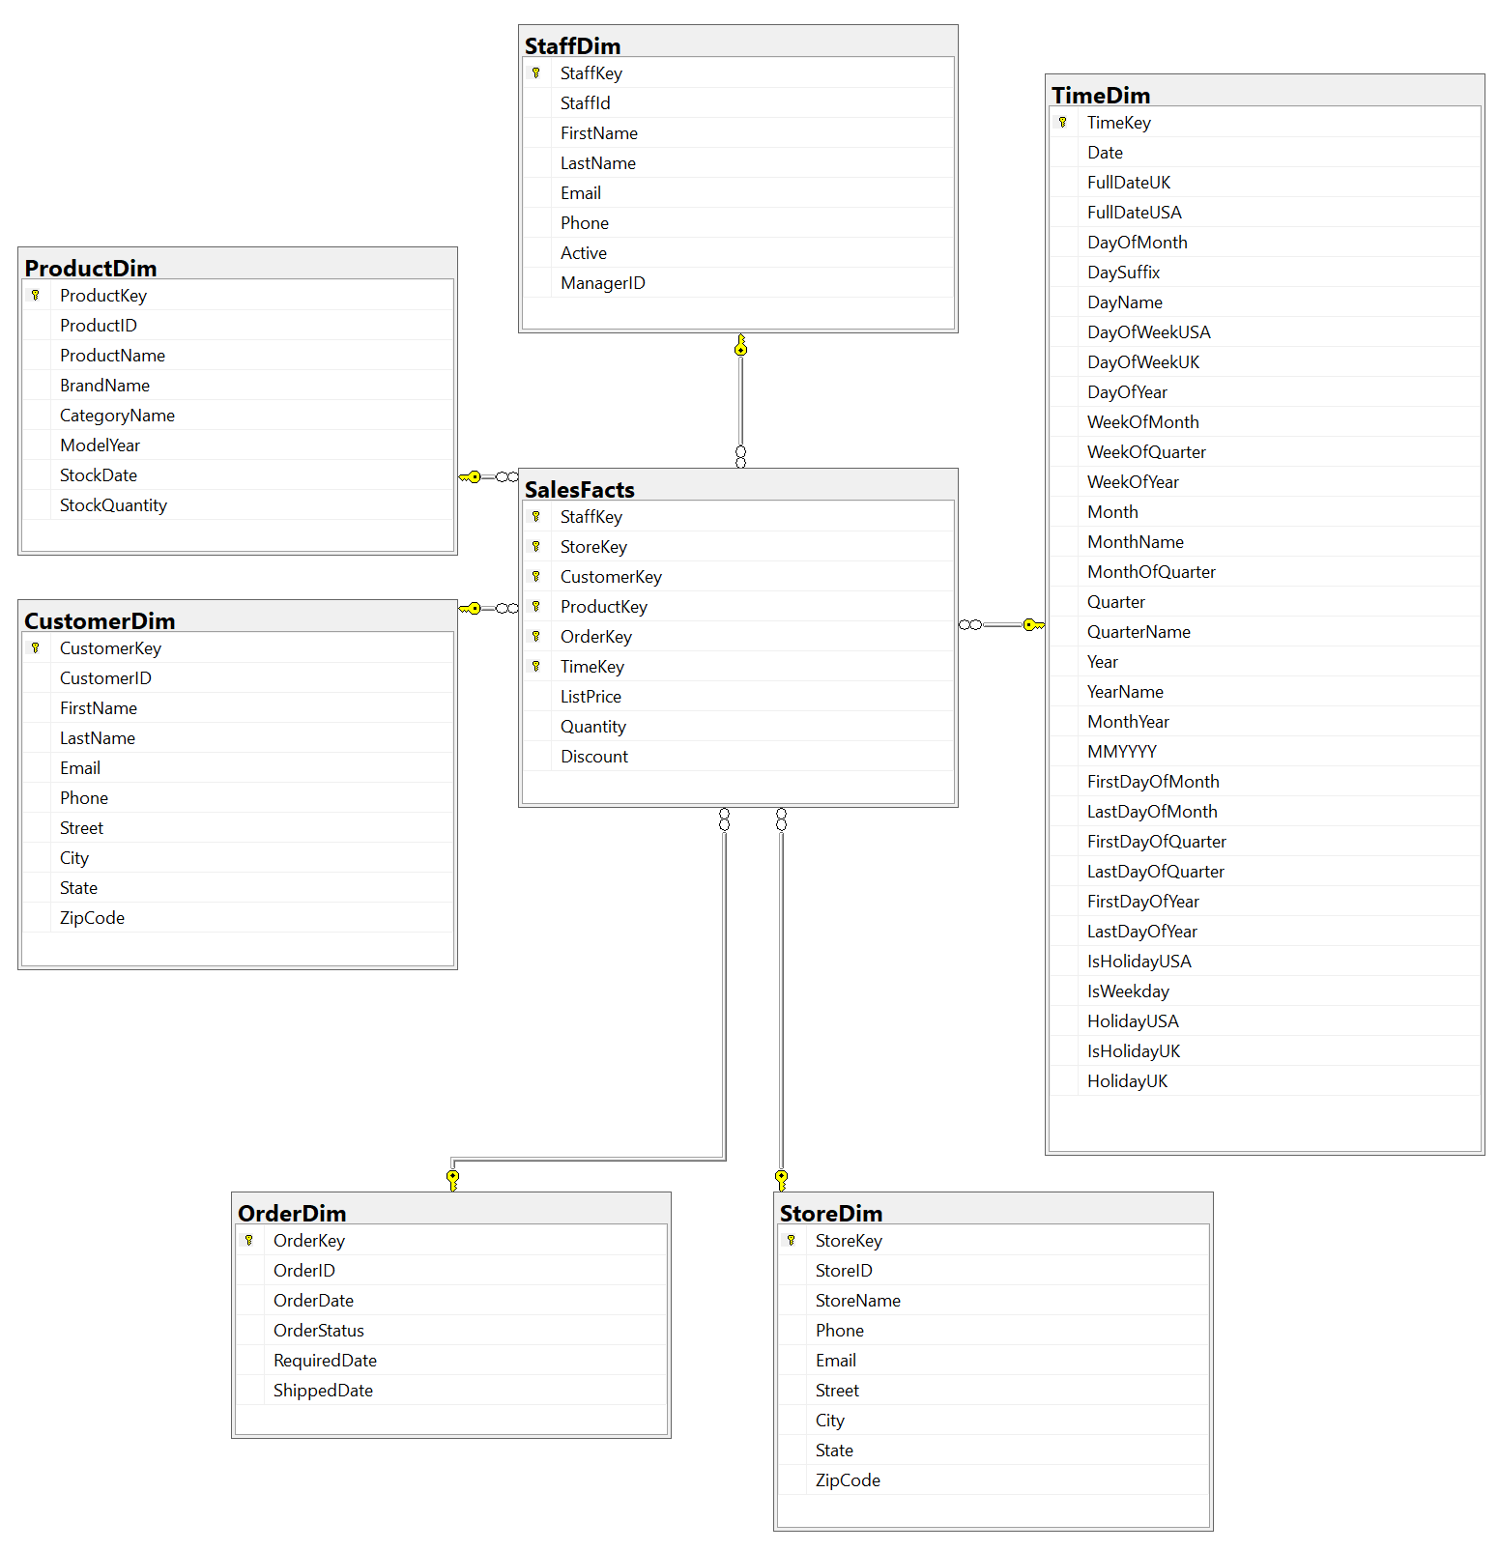

Queries explanation
Query | Explanation | SQL script
1 | This query is to get the highest spending customer for the month and view which brand and categories were these customers buying from. We use rank to rank all the customers in the month by the total money they spend in that month.  Insights:  - We could see that the most popular purchases were from trek and mountain/road bikes.  - Comparing all the top customer for each month , we can see that Abby Gamble spend the most in Apr 2018 at $25574.96 while Latasha Hays spend the least in June 2018 at 188.99. | SELECT Date, [Customer Name], Brand,  Category, Quantity, [Total Sales]  FROM  (  SELECT td.MonthYear 'Date',  CONCAT(c.FirstName,' ',c.LastName) 'Customer Name',  p.BrandName 'Brand',  p.CategoryName 'Category',  SUM(sf.Quantity) AS 'Quantity',  CAST(  SUM(sf.Quantity*sf.ListPrice*(1-sf.Discount))  AS DECIMAL (10,2))  AS 'Total Sales',  RANK () OVER (  PARTITION BY td.MonthYear  ORDER BY (  SUM(sf.Quantity*sf.ListPrice*(1-sf.Discount))  ) DESC) 'Sales_rank'  FROM TimeDim td, SalesFacts sf,  ProductDim p , CustomerDim c  WHERE td.TimeKey = sf.TimeKey  AND p.ProductKey = sf.ProductKey  AND c.CustomerKey=sf.CustomerKey  GROUP BY td.MonthYear, p.BrandName,  p.CategoryName, CONCAT(c.FirstName,' ',c.LastName)  ) AS ranking WHERE ranking.Sales_rank = 1
2 | This query is to get the best staff for each product price range. We choose the price range based on the interqualitle range of all the prices of the products.  Insights:  - Baldwin bikes has the best sales compared to the other 2 stores since its staff top the charts for the highest sales across all price range.  - Rowlett Bikes has the worst sales among the 3 stores.  - Venita Daniel sold the most products that are listed in high price and low price while Marcelene Boyer had the highest sales for products listed in medium price.  - The quantity of bikes sold in the lowest price range was the highest at 2915 while the bikes in the highest price range was the lowest at 1443. | SELECT prt.StaffKey,  CONCAT(sd.FirstName,' ',sd.LastName) Name,  store.StoreName, prt.PriceRange,  AVG(prt.Discount) AS AvgDiscount,  SUM(prt.Quantity) AS TotalQuantity,  SUM(prt.Quantity*prt.ListPrice*(1-prt.Discount)) AS TotalSales  FROM (SELECT s.*,  CASE  WHEN s.ListPrice < 500 THEN 'Low Price'  WHEN s.ListPrice < 1700 THEN 'Medium Price'  ELSE 'High Price'  END AS PriceRange  FROM SalesFacts AS s) AS prt,  StaffDim AS sd, StoreDim AS store  WHERE prt.StaffKey = sd.StaffKey AND store.StoreKey = prt.StoreKey  GROUP BY prt.PriceRange, CONCAT(sd.FirstName,' ',sd.LastName),  store.StoreName, prt.StaffKey  ORDER BY  CASE  WHEN prt.PriceRange = 'High Price' THEN 1  WHEN prt.PriceRange = 'Medium Price' THEN 2  ELSE 3 END,  7 DESC
3 | This query to get the quarterly Revenue of the Company and compare with the previous quarter’s Revenue by calculating Percentage Change .  Insights:  - The companies revenue generally have a Decrease in the 4th Quarter.  - 2019 3rd Quarter the company experienced an extremely large decrease in sales dropping 96.49% compared to 2019 2nd Quarter  - In the last 3 recorded quarters , Revenue has been decreasing | SELECT QuarterData.LastDayOfQuarter,  CONCAT('Q', QuarterData.Quarter) AS 'Quarter', Revenue,  LAG(Revenue,1) OVER (ORDER BY QuarterData.LastDayOfQuarter) AS 'Previous Revenue',  FORMAT(  (Revenue - LAG(Revenue,1) OVER (ORDER BY QuarterData.LastDayOfQuarter))  /  LAG(Revenue,1) OVER (ORDER BY QuarterData.LastDayOfQuarter),  'P'  ) AS 'Percentage Change',  CASE  WHEN LAG(Revenue,1) OVER (ORDER BY QuarterData.LastDayOfQuarter) IS NULL THEN NULL  WHEN (Revenue - LAG(Revenue,1) OVER (ORDER BY QuarterData.LastDayOfQuarter)) > 0 THEN 'INCREASE'  ELSE 'DECREASE' END AS 'Trend'  FROM (  SELECT t.LastDayOfQuarter, t.Quarter,  SUM(s.Quantity*s.ListPrice*(1-s.Discount)) AS 'Revenue'  FROM SalesFacts s, TimeDim t, OrderDim o  WHERE s.TimeKey = t.TimeKey  GROUP BY t.LastDayOfQuarter, t.Quarter  ) AS QuarterData
4 | This query displays a summarised record of the top 25 customers that have spent the most on Trek Bicycle Store Inc from the start.  Insights:  - Sharyn Hopkins is the customer that has spent the most money on Trek Bicycle Store Inc, spending $34.8k  - Of the top 25 customers, the number of purchases range from 4 to 10. The maximum number of purchases of 10 has occurred 5 times  - The highest average transaction cost among the top 25 ranges from $2k to $6.2k  - Majority of the top 25 customers live in New York | SELECT TOP 25 CASE  WHEN C.State = 'CA' THEN 'California'  WHEN C.State = 'NY' THEN 'New York'  WHEN C.State = 'TX' THEN 'Texas'  ELSE 'Unknown' END AS 'State',  CONCAT(C.FirstName, ' ', C.LastName) 'Customer',  CAST(ROUND(SUM(SF.ListPrice*(1-SF.Discount)*SF.Quantity),2) AS NUMERIC(10,2)) 'Amount Spent',  COUNT(OrderID) 'Number of Purchases',  CAST(ROUND(SUM(SF.ListPrice*(1-SF.Discount)*SF.Quantity)/COUNT(OrderID),2) AS NUMERIC(10,2)) 'Average Transaction Cost'  FROM CustomerDim AS C, SalesFacts AS SF, OrderDim AS O  WHERE C.CustomerKey = SF.CustomerKey AND O.OrderKey = SF.OrderKey  AND O.OrderStatus != 3  GROUP BY C.State, CONCAT(C.FirstName, ' ', C.LastName)  ORDER BY SUM(SF.ListPrice*(1-SF.Discount)*SF.Quantity) DESC
5 | This query provides us with records of total sales and total stocks for each unique category and brand.This also includes Stocks to Sales Ratio with is an metrics which shows whether a product is overstocked , understocked or just nice.  Insights:  - The Cruisers Bicycle cateogry has the lowest StockSalesRatio at 0.28 which means that cruisers bicycle is understocked  - The Electric Bikes category has the highest StockSalesRatio at 14.75 which means that cruisers bicycles is overstocked  - Generally the Company has been managing it’s inventory well with only Eletric Bikes having an extreme StockSalesRatio  - One reason of these happening is because of the price of the product , electric bicycle is more expensive at $2849 which results in a lower sales | SELECT Temp.CategoryName, Temp.BrandName,  CAST(ROUND(AVG(Temp.AvgPrice),2) AS NUMERIC(6,2)) AvgPrice,  SUM(SalesQuantity) TotalSales, SUM(StockQuantity) TotalStocks,  CAST(ROUND(SUM(StockQuantity)/SUM(SalesQuantity),2) AS NUMERIC(5,2)) AS StockSalesRatio  FROM (  SELECT p.ProductKey,p.CategoryName,p.BrandName,  ISNULL(SUM(sf.Quantity),0) SalesQuantity, AVG(p.StockQuantity) StockQuantity ,  AVG(sf.ListPrice) as AvgPrice  FROM ProductDim AS p LEFT JOIN SalesFacts AS sf ON p.ProductKey = sf.ProductKey  GROUP BY p.ProductKey,p.CategoryName,p.BrandName  ) AS Temp  GROUP BY Temp.CategoryName, Temp.BrandName  ORDER BY 6 ASC

